Assignment: Recognizing Adaptive Evolution in Daily Life
(remember to not include your name in this file – your submission is linked to your canvas profile)

Paste picture here:
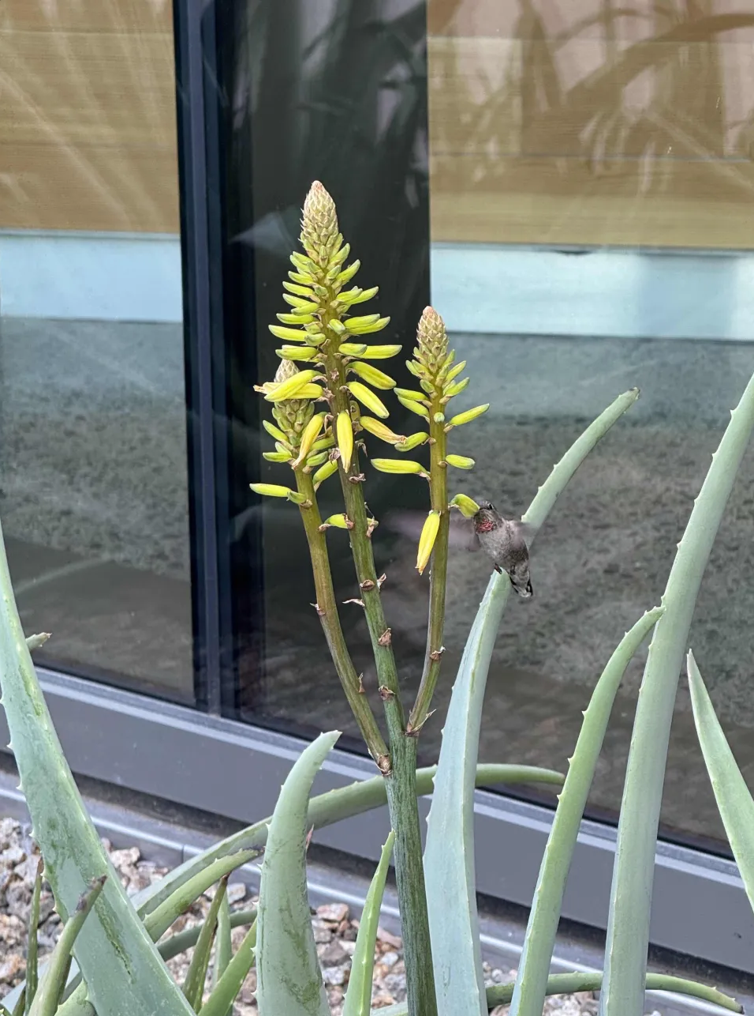
Questions:
- What is the organism and trait you are using as an example? (Clearly describe a specific morphological, physiological, or behavioral trait.)
The organism I am using as an example is a hummingbird and the particular trait I’m interested in is the hummingbird’s ability to hover in mid-air.

- What is your adaptive hypothesis? (How might this trait enhance survival or reproduction in the organism's environment?)
My adaptive hypothesis is that the adaptation to hover mid-air was selected for because it allowed hummingbirds to access the nectar inside tubular flowers, which is otherwise difficult to access. Since this adaptation allows hummingbirds to access their food source, it directly enhances their survival and contributes to the organism’s overall fitness.
- What could be an alternative, non-adaptive explanation for this trait? (What other mechanism than natural selection could produce that trait?)
An alternative explanation is that the trait was shaped by genetic drift. In a bottleneck scenario, there could have been a random mutation that allowed for better control over flapping their wings that existed in a population of hummingbirds. When a random event occurs that randomly wipes out most of the population, it could be possible by pure chance that the individuals with the mutation survived and soon the trait reaches fixation in the surviving population.

